Experiment No. 1

Flight Reservation System (SaaS)

Aim
To create a cloud-based Flight Reservation System using Zoho Creator to demonstrate the Software as a Service (SaaS) model. The application enables users to book flight tickets by entering travel details, and securely stores the reservation information in the cloud.

Software/Tools Required
- Zoho Creator
- Web Browser (Google Chrome/Microsoft Edge)
- Zoho Account
- Internet Connection

Algorithm
- Log in to the Zoho Creator platform.
- Create a new application named Flight Reservation System.
- Design a form for flight booking.
- Add all the required fields with appropriate data types.
- Configure validation rules and dropdown values wherever necessary.
- Save the application and submit sample booking details.
- Verify that the data is stored successfully in the cloud database.

Form Fields
Field Name | Field Type
Passenger Name | Single Line
Trip Type | Dropdown (One Way/Round Trip)
From | Single Line
To | Single Line
Departure Date | Date
Return Date | Date
Number of Travellers | Number
Travel Class | Dropdown
Fare Type | Dropdown
Flight Type | Dropdown (Domestic/International)
Contact Number | Phone
Email Address | Email

Output
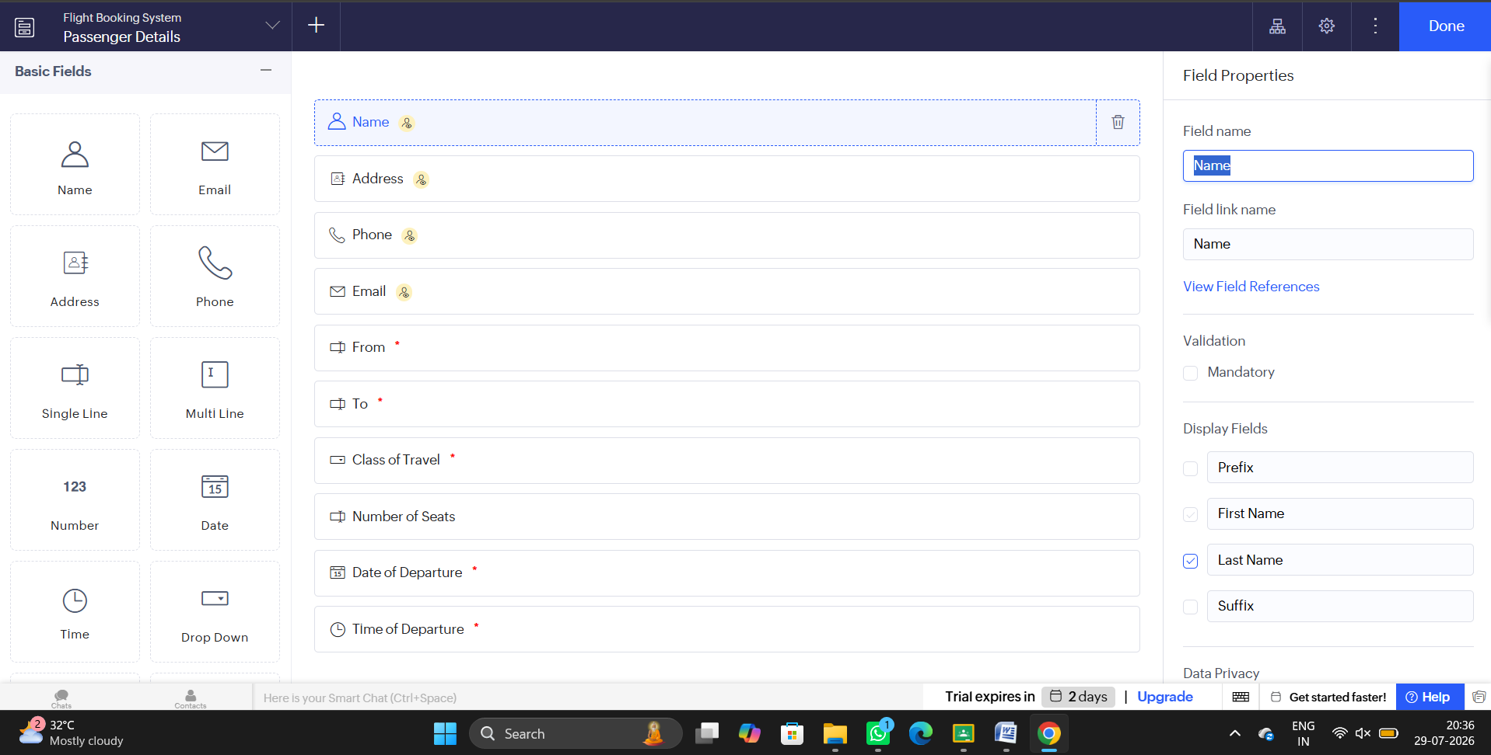

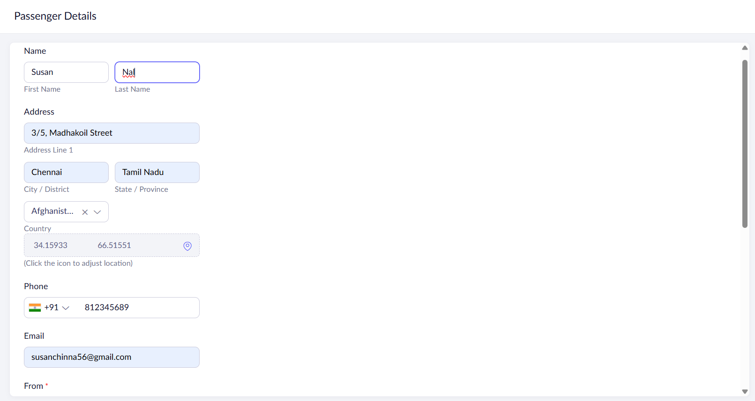

Result
Thus, a cloud-based Flight Reservation System was successfully developed using Zoho Creator to demonstrate the Software as a Service (SaaS) model. The application allows users to reserve flights online, while storing and managing booking details securely in the cloud.

Experiment No. 2

Property Buying & Rental System (Chennai) – SaaS

Aim
To create a cloud-based Property Buying and Rental System using Zoho Creator to demonstrate the Software as a Service (SaaS) model. The application allows customers to buy or rent residential and commercial properties in Chennai by submitting their property requirements online.

Software/Tools Required
- Zoho Creator
- Web Browser (Google Chrome/Microsoft Edge)
- Zoho Account
- Internet Connection

Algorithm
- Log in to Zoho Creator.
- Create a new application named Property Buying & Rental System.
- Design a property enquiry form.
- Add all the required fields with suitable data types.
- Configure dropdown options and validation rules.
- Save the application and submit sample property details.
- Verify that the records are stored successfully in the cloud database.

Form Fields
Field Name | Field Type
Customer Name | Single Line
Mobile Number | Phone
Email Address | Email
Property Requirement | Dropdown (Buy/Rent)
Property Type | Dropdown (Residential/Commercial)
Rental Agreement | Checkbox
Area (Sq.ft.) | Number
Preferred Location | Single Line
Budget Range | Currency
Property Value | Currency
Number of Bedrooms | Dropdown
Possession Date | Date
Additional Requirements | Multi Line

Output
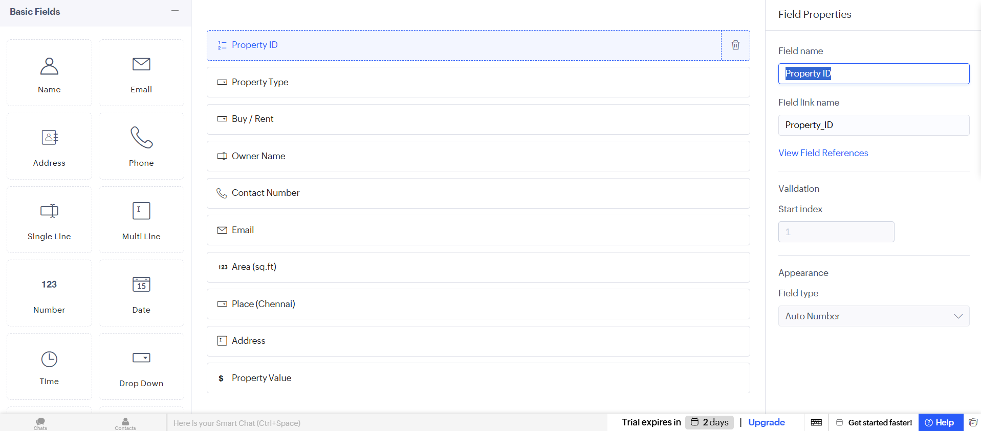

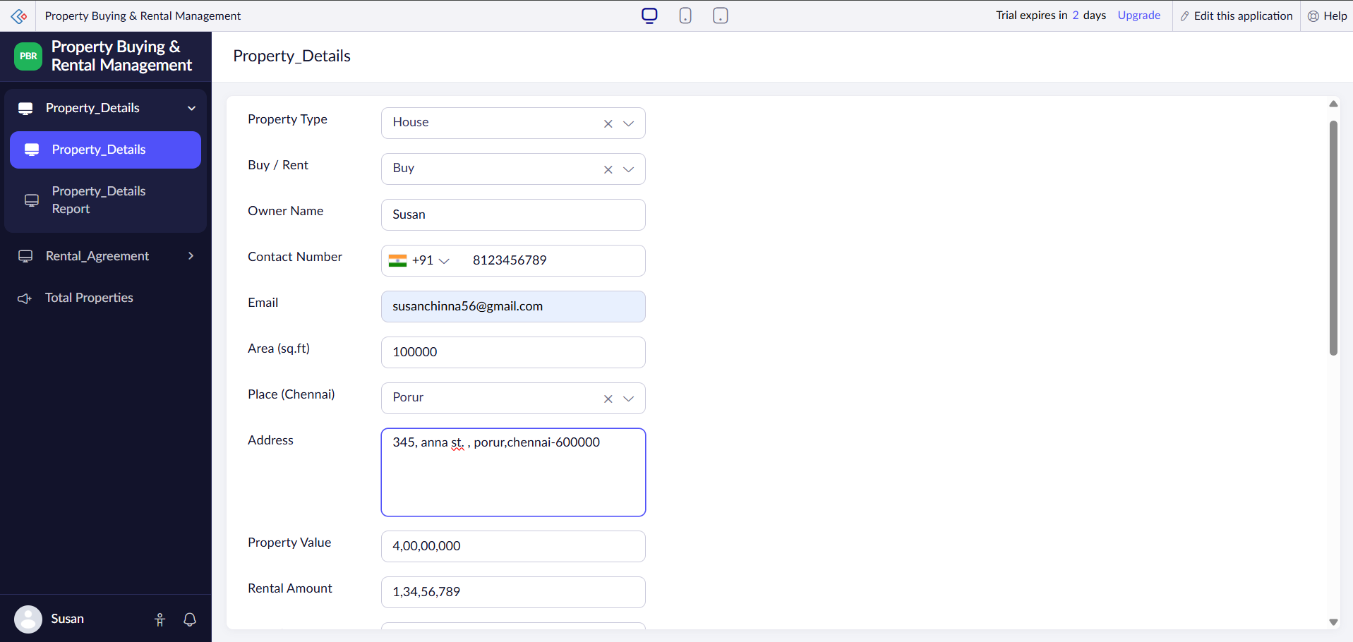

Result
Thus, a cloud-based Property Buying and Rental System was successfully developed using Zoho Creator to demonstrate the Software as a Service (SaaS) model. The application enables customers to submit property requirements, search for suitable properties, and securely store enquiry details in the cloud for easy access and management.

Experiment No. 3

Car Booking Reservation System – SaaS

Aim
To create a cloud-based Car Booking Reservation System using Zoho Creator to demonstrate the Software as a Service (SaaS) model. The application enables users to book cars for local, rental, and outstation travel while storing booking information securely in the cloud.

Software/Tools Required
- Zoho Creator
- Web Browser (Google Chrome/Microsoft Edge)
- Zoho Account
- Internet Connection

Algorithm
- Log in to Zoho Creator.
- Create a new application named Car Booking Reservation System.
- Design the car booking form.
- Add all required booking and customer details with appropriate field types.
- Configure dropdown values and validation rules.
- Save the application and submit sample booking information.
- Verify that the booking details are stored successfully in the cloud.

Form Fields
Field Name | Field Type
Customer Name | Single Line
Mobile Number | Phone
Email Address | Email
Cab Type | Dropdown
Pickup Location | Single Line
Destination | Single Line
Trip Type | Dropdown (Local/Rental/Outstation)
Package Type | Dropdown
Rental Duration | Number
Pickup Date | Date
Pickup Time | Time
Number of Passengers | Number
Payment Method | Dropdown
Special Requests | Multi Line

Output 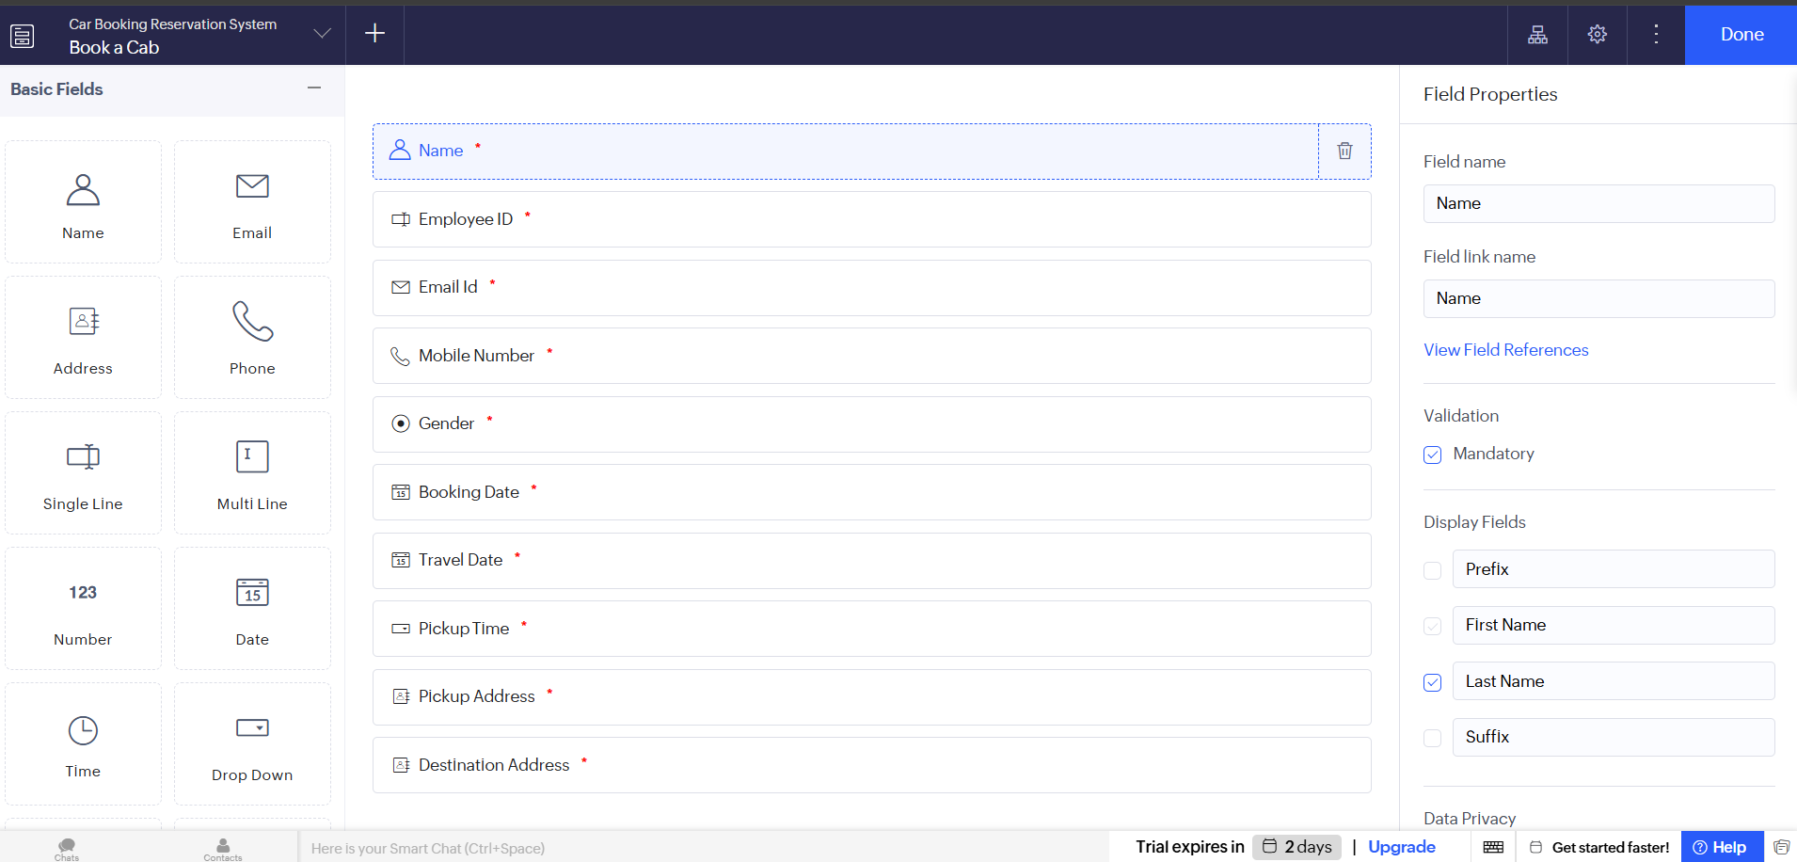

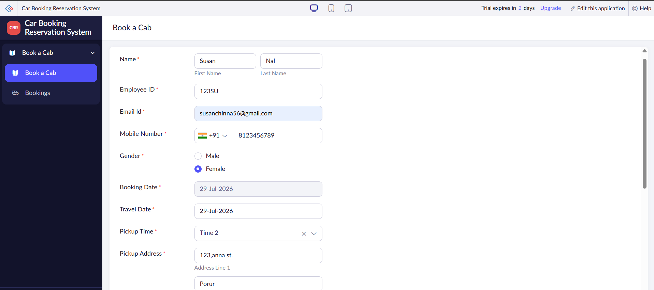

Result
Thus, a cloud-based Car Booking Reservation System was successfully developed using Google AppSheet to demonstrate the Software as a Service (SaaS) model. The application allows customers to reserve cabs conveniently, stores booking information securely in the cloud, and provides an efficient platform for managing travel reservations.

Experiment No. 4

Library Book Reservation System for SIMATS Library – SaaS

Aim
To create a cloud-based Library Book Reservation System for SIMATS Library using Zoho Creator to demonstrate the Software as a Service (SaaS) model. The application helps students reserve books, track availability, and maintain library records through cloud-based storage.

Software/Tools Required
- Zoho Creator
- Web Browser (Google Chrome/Microsoft Edge)
- Zoho Account
- Internet Connection

Algorithm
- Log in to Zoho Creator.
- Create a new application named Library Book Reservation System.
- Design a book reservation form.
- Add all required book and student details with appropriate field types.
- Configure dropdown values and validation rules.
- Save the application and submit sample reservation details.
- Verify that the reservation records are stored successfully in the cloud.

Form Fields
Field Name | Field Type
Student Name | Single Line
Register Number | Single Line
Book Title | Single Line
Author | Single Line
Publication | Single Line
Year of Publication | Number
Edition | Single Line
Number of Copies | Number
Rack Number | Single Line
Book Status | Dropdown (Available/Taken/Returned/Reserved)
Reservation Date | Date
Return Date | Date
Librarian Name | Single Line
Remarks | Multi Line

Output
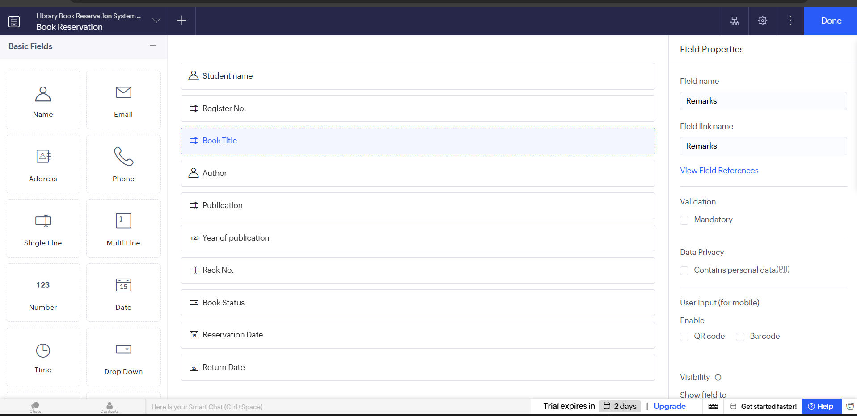

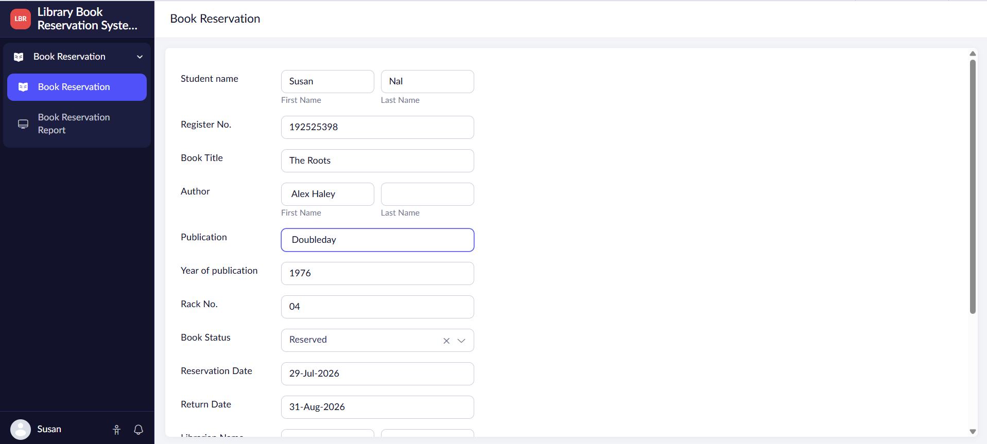

Result
Thus, a cloud-based Library Book Reservation System was successfully created using Zoho Creator. The application allows students to reserve books, monitor their availability, and manage reservation records securely through the cloud, demonstrating the SaaS model.

Experiment No. 5

Mark Sheet Processing System – SaaS

Aim
To create a cloud-based Mark Sheet Processing System using Zoho Creator to demonstrate the Software as a Service (SaaS) model. The application enables users to enter student details and marks, automatically calculate the average, percentage, and overall performance, and securely store the records in the cloud.

Software/Tools Required
- Zoho Creator
- Web Browser (Google Chrome/Microsoft Edge)
- Zoho Account
- Internet Connection

Algorithm
- Log in to Zoho Creator.
- Create a new application named Mark Sheet Processing System.
- Design a student mark entry form.
- Add all the required fields with appropriate field types.
- Configure formulas to calculate Total Marks, Average, Percentage, and Overall Performance.
- Save the application and enter sample student records.
- Verify that the calculated results and student information are stored successfully in the cloud database.

Form Fields
Field Name | Field Type
Student Name | Single Line
Register Number | Single Line
Department | Dropdown
Semester | Number
Subject 1 | Number
Subject 2 | Number
Subject 3 | Number
Subject 4 | Number
Subject 5 | Number
Total Marks | Formula (Number)
Average | Formula (Decimal)
Percentage | Formula (Percentage/Decimal)
Rank | Number
Overall Performance | Dropdown (Excellent/Very Good/Good/Average/Fail)
Remarks | Multi Line

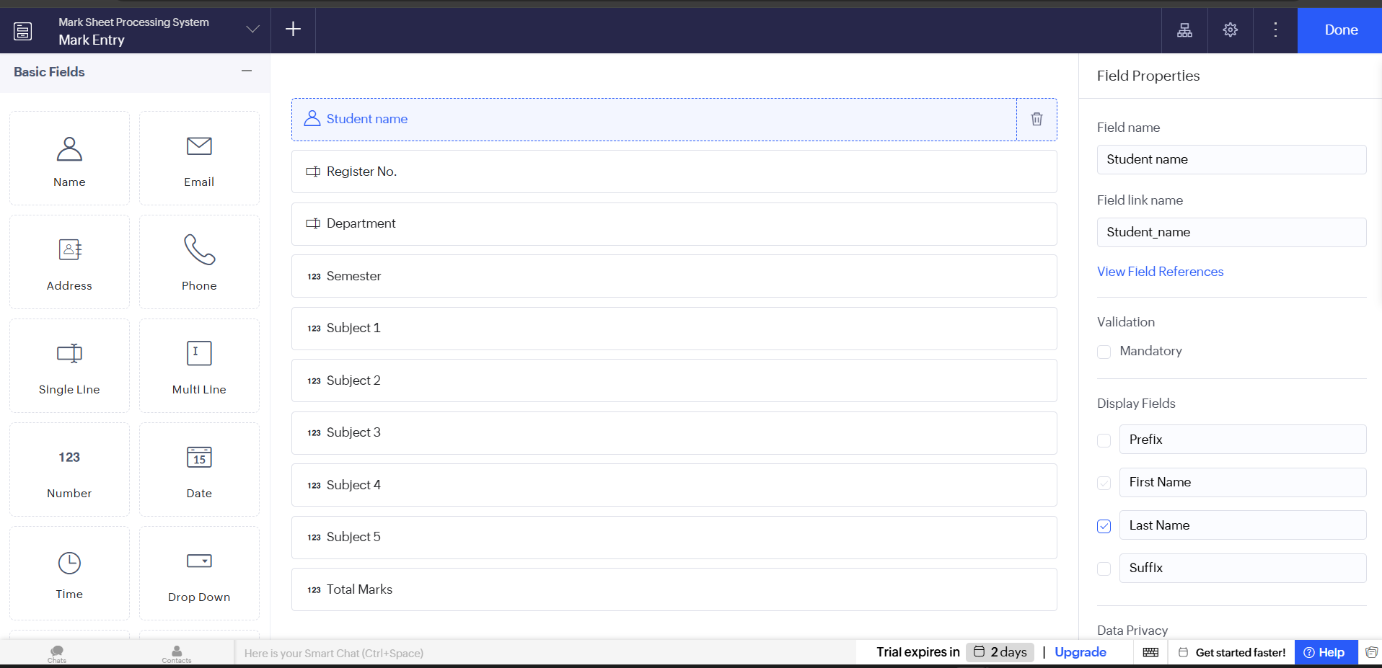
Output

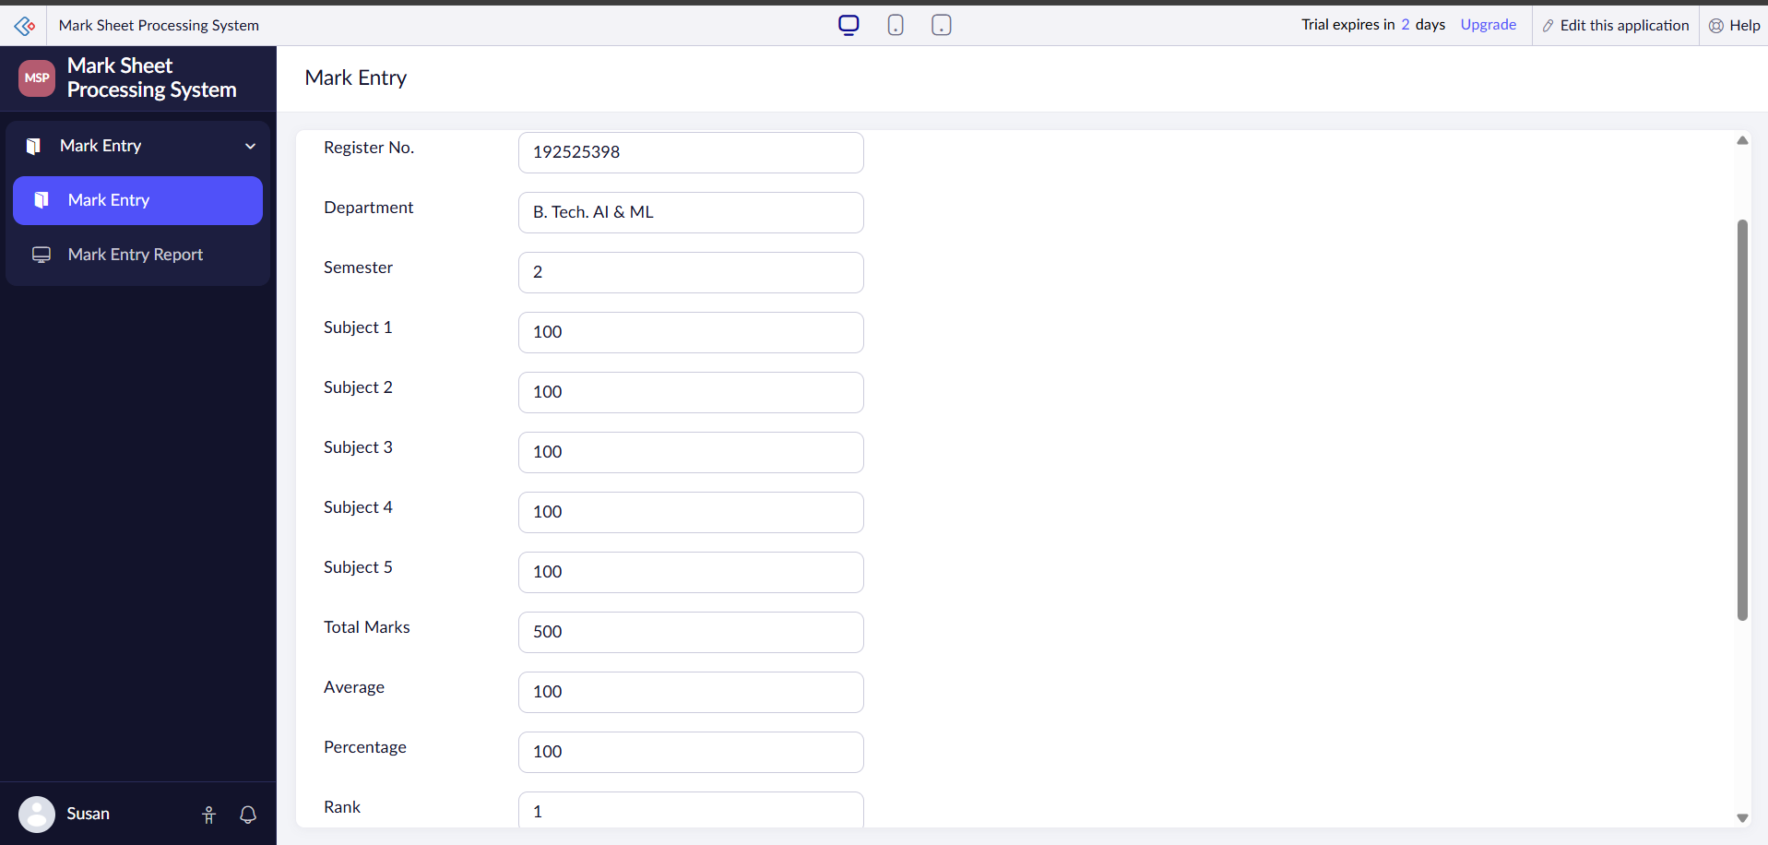

Result
Thus, a cloud-based Mark Sheet Processing System was successfully created using Zoho Creator. The application calculates the student's total marks, average, percentage, and overall performance automatically while securely storing the academic records in the cloud, thereby demonstrating the Software as a Service (SaaS) model.

Experiment No. 6

Payroll Processing System – SaaS

Aim
To create a cloud-based Payroll Processing System using Zoho Creator to demonstrate the Software as a Service (SaaS) model. The application enables organizations to manage employee salary details, automatically calculate gross pay and net pay, and securely maintain payroll records in the cloud.

Software/Tools Required
- Zoho Creator
- Web Browser (Google Chrome/Microsoft Edge)
- Zoho Account
- Internet Connection

Algorithm
- Log in to Zoho Creator.
- Create a new application named Payroll Processing System.
- Design an employee payroll form.
- Add all the required employee and salary-related fields with appropriate field types.
- Configure formulas to calculate Gross Pay and Net Pay automatically.
- Save the application and enter sample employee payroll details.
- Verify that the payroll information is calculated correctly and stored successfully in the cloud database.

Form Fields
Field Name | Field Type
Employee Name | Single Line
Employee ID | Single Line
Department | Dropdown
Designation | Single Line
Experience in Present Organization | Number
Overall Experience | Number
Basic Pay | Currency
HRA | Currency
DA | Currency
TA | Currency
Other Allowances | Currency
Gross Pay | Formula (Currency)
Deductions | Currency
Net Pay | Formula (Currency)
Payment Date | Date
Remarks | Multi Line

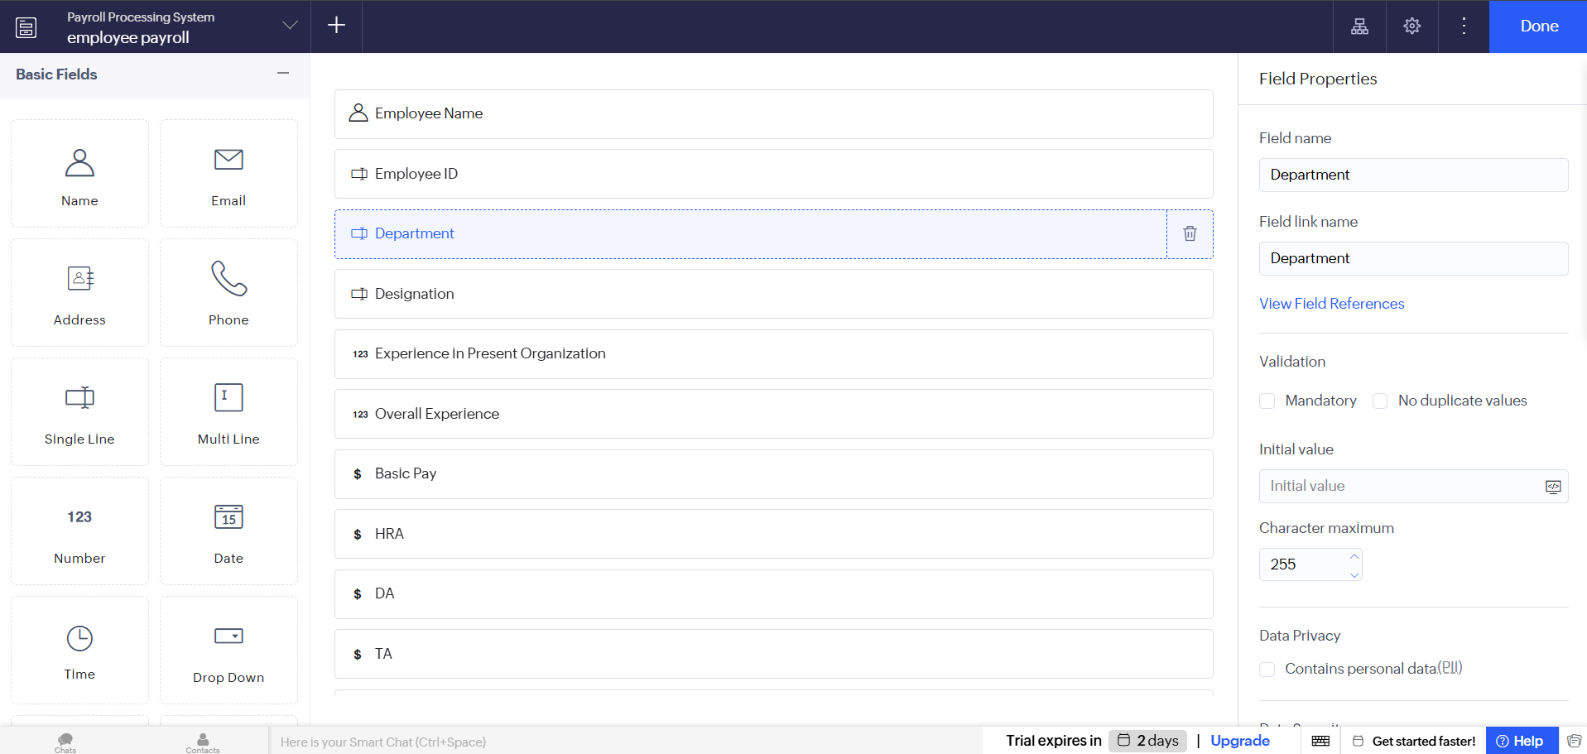
Output

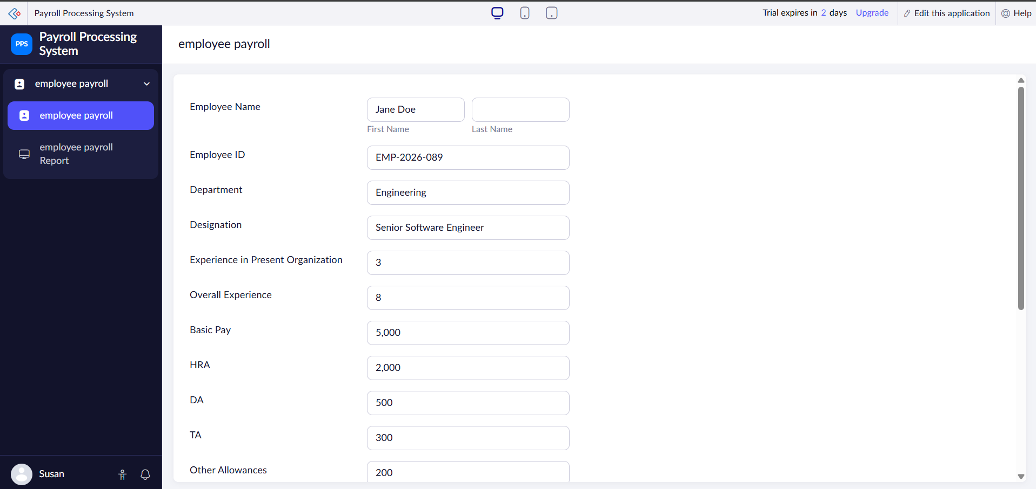

Result
Thus, a cloud-based Payroll Processing System was successfully created using Zoho Creator. The application automatically calculates the employee's gross pay and net pay based on the salary components, securely stores payroll information in the cloud, and effectively demonstrates the Software as a Service (SaaS) model.

Experiment No. 7

Students Attendance System – SaaS

Aim
To create a cloud-based Students Attendance System using Zoho Creator to demonstrate the Software as a Service (SaaS) model. The application enables faculty members to record student attendance, calculate attendance percentage, manage OD (On Duty) requests, and securely store attendance records in the cloud.

Software/Tools Required
- Zoho Creator
- Web Browser (Google Chrome/Microsoft Edge)
- Zoho Account
- Internet Connection

Algorithm
- Log in to Zoho Creator.
- Create a new application named Students Attendance System.
- Design an attendance management form.
- Add all the required student and attendance-related fields with appropriate field types.
- Configure formulas to calculate the attendance percentage automatically based on the number of classes attended.
- Save the application and enter sample attendance records.
- Verify that the attendance details are stored correctly and displayed in the cloud database.

Form Fields
Field Name | Field Type
Student Name | Single Line
Register Number | Single Line
Course | Dropdown
Department | Dropdown
Semester | Number
Total Classes Conducted | Number
Classes Attended (Present) | Number
Classes Missed (Absent) | Number
Attendance Percentage | Formula (Percentage/Decimal)
Course Attendance Status | Dropdown (Eligible/Not Eligible)
OD Request | Checkbox
Grade | Dropdown
Faculty Name | Single Line
Remarks | Multi Line

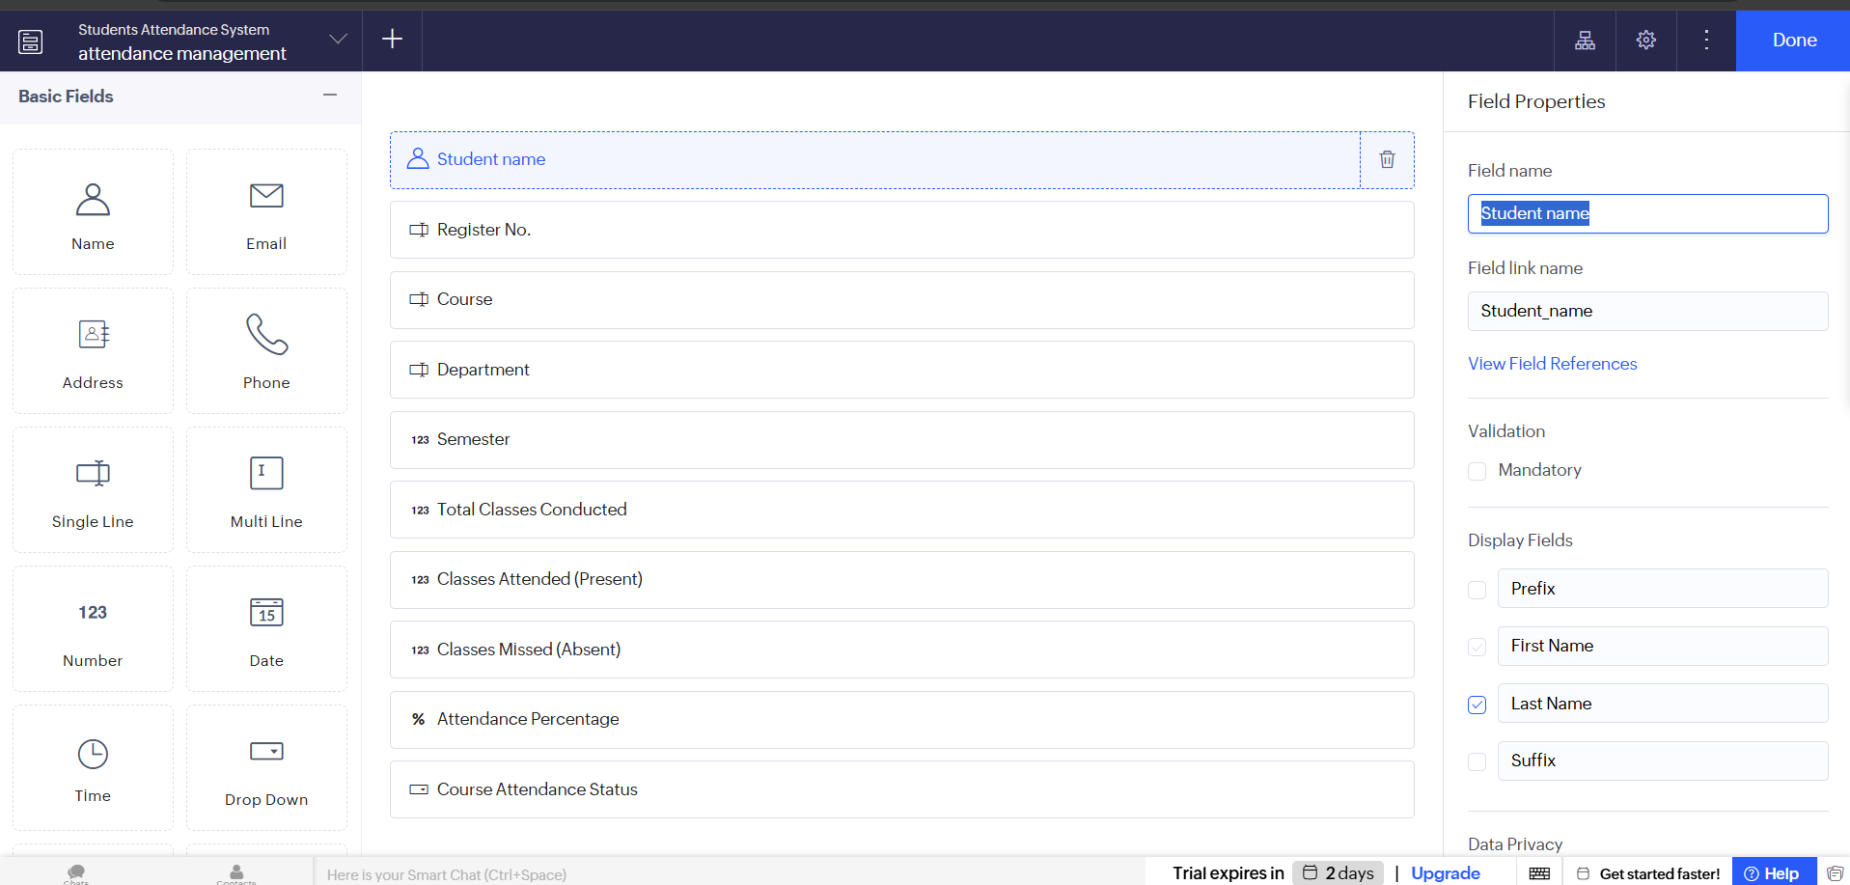
Output

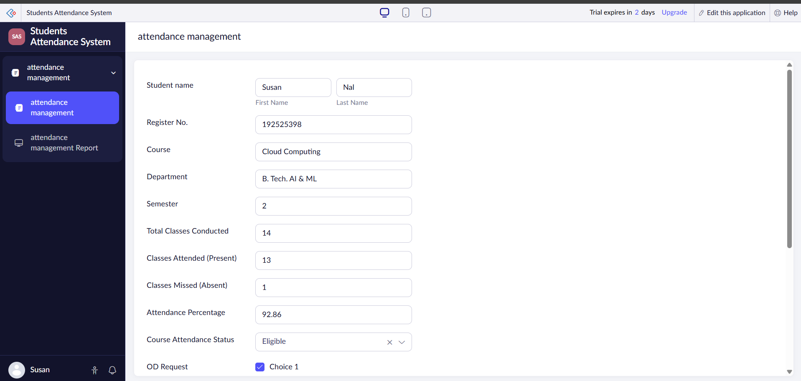

Result
Thus, a cloud-based Students Attendance System was successfully created using Zoho Creator. The application efficiently manages student attendance records, automatically calculates attendance percentages, processes OD requests, and securely stores all information in the cloud, thereby demonstrating the Software as a Service (SaaS) model.

Experiment No. 8

Student Counselling System – SaaS

Aim
To create a cloud-based Student Counselling System using Zoho Creator to demonstrate the Software as a Service (SaaS) model. The application enables students to register for counselling by providing their personal, academic, and career-related details, while securely storing the information in the cloud for easy access by counsellors.

Software/Tools Required
- Zoho Creator
- Web Browser (Google Chrome/Microsoft Edge)
- Zoho Account
- Internet Connection

Algorithm
- Log in to Zoho Creator.
- Create a new application named Student Counselling System.
- Design a student counselling registration form.
- Add all the required personal, academic, and counselling-related fields with appropriate field types.
- Configure validation rules and dropdown options wherever necessary.
- Save the application and enter sample student counselling details.
- Verify that the submitted information is stored successfully in the cloud database and can be accessed when required.

Form Fields
Field Name | Field Type
Student Name | Single Line
Register Number | Single Line
Age | Number
Gender | Dropdown
Address | Multi Line
Phone Number | Phone
Email Address | Email
Subjects Studied | Multi Line
Year of Passing | Number
Percentage of Marks | Decimal
Domain Interest | Dropdown (AI & ML/Web Development/Data Science/Cyber Security/Cloud Computing/Others)
Career Goal | Multi Line
Preferred Counselling Date | Date
Counsellor Name | Single Line
Remarks | Multi Line

Output

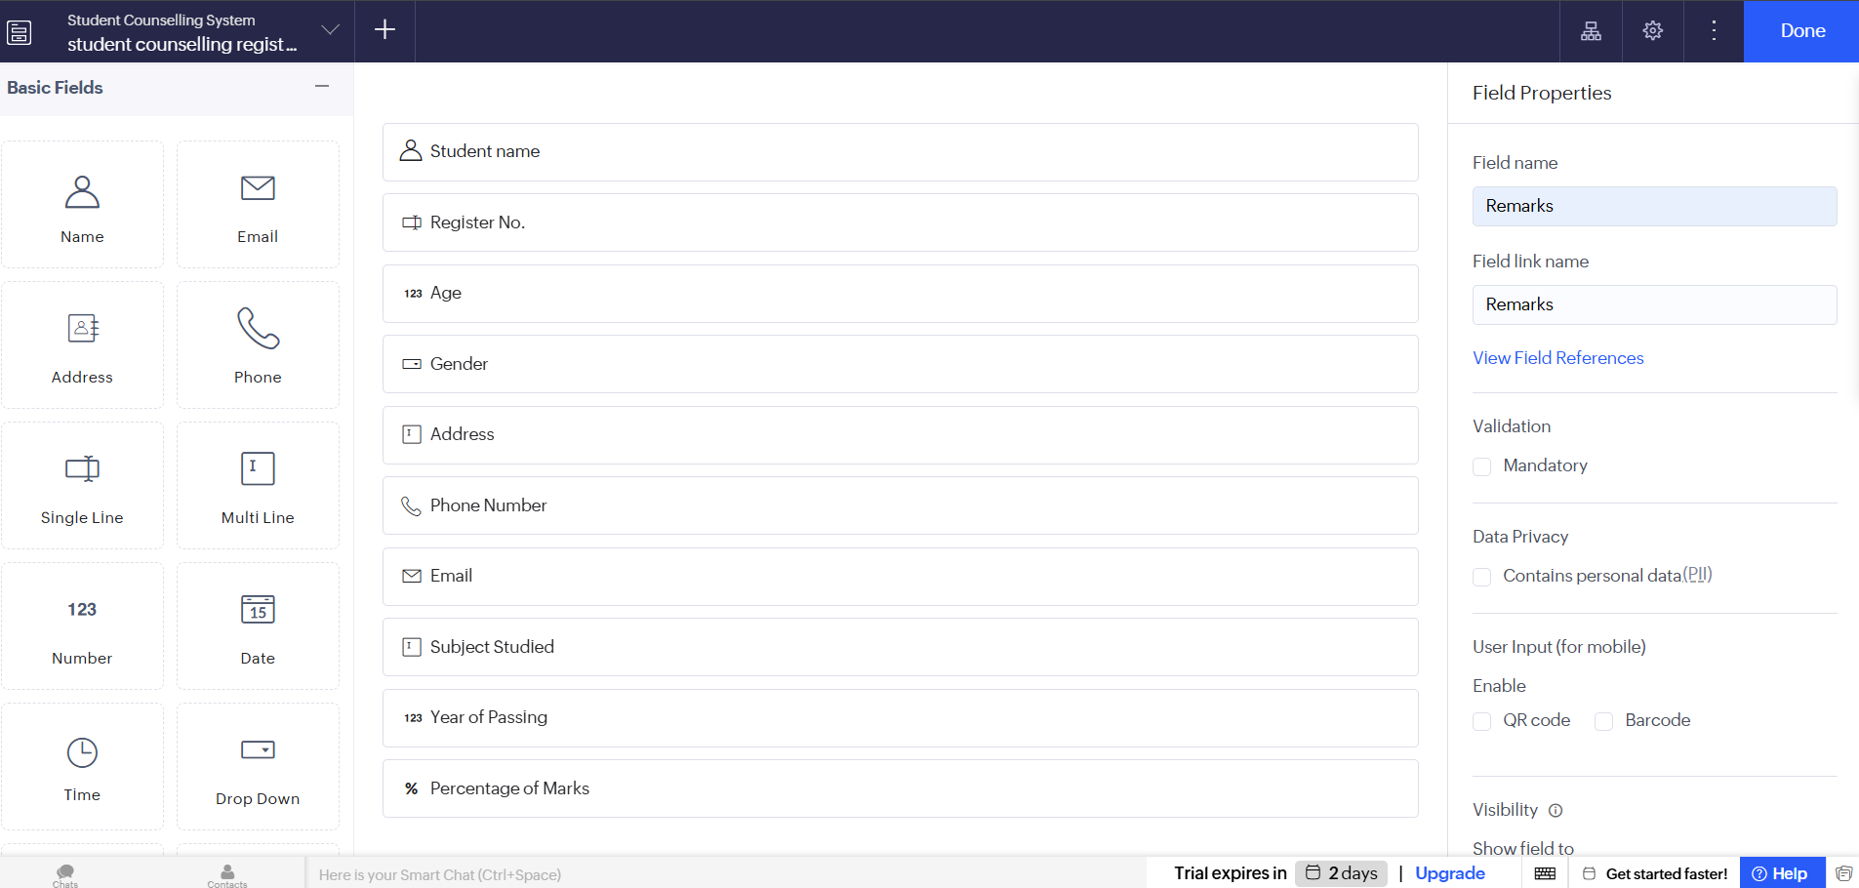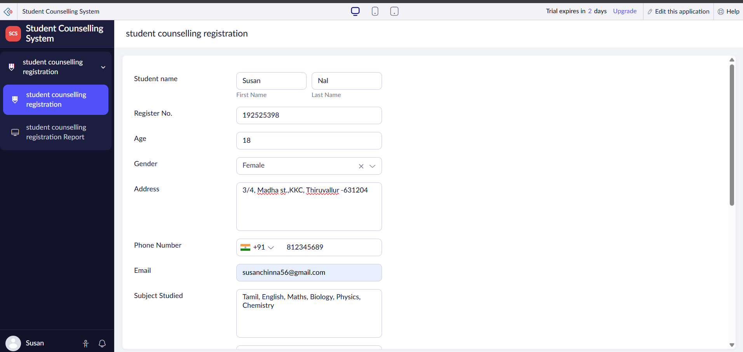

Result
Thus, a cloud-based Student Counselling System was successfully created using Zoho Creator. The application allows students to submit their academic and personal details for counselling, securely stores the information in the cloud, and enables counsellors to manage student records efficiently, thereby demonstrating the Software as a Service (SaaS) model.

Experiment No. 9

Hospital Information System for SIMATS Hospital – SaaS

Aim
To create a cloud-based Hospital Information System for SIMATS Hospital using Zoho Creator to demonstrate the Software as a Service (SaaS) model. The application enables hospital staff to register patients, maintain medical records, and securely store patient information in the cloud for efficient access and management.

Software/Tools Required
- Zoho Creator
- Web Browser (Google Chrome/Microsoft Edge)
- Zoho Account
- Internet Connection

Algorithm
- Log in to Zoho Creator.
- Create a new application named Hospital Information System.
- Design a patient registration form.
- Add all the required patient, attender, and medical information fields with appropriate field types.
- Configure validation rules and dropdown options wherever necessary.
- Save the application and enter sample patient records.
- Verify that the patient information is stored successfully in the cloud database and can be accessed for future reference.

Form Fields
Field Name | Field Type
Patient Name | Single Line
Patient ID | Single Line
Age | Number
Gender | Dropdown
Address | Multi Line
Phone Number | Phone
Email Address | Email
Attender Name | Single Line
Attender Phone Number | Phone
Doctor Name | Single Line
Department | Dropdown
Disease / Diagnosis | Multi Line
Date of Admission | Date
Date of Discharge | Date
Blood Group | Dropdown
Medical Remarks | Multi Line

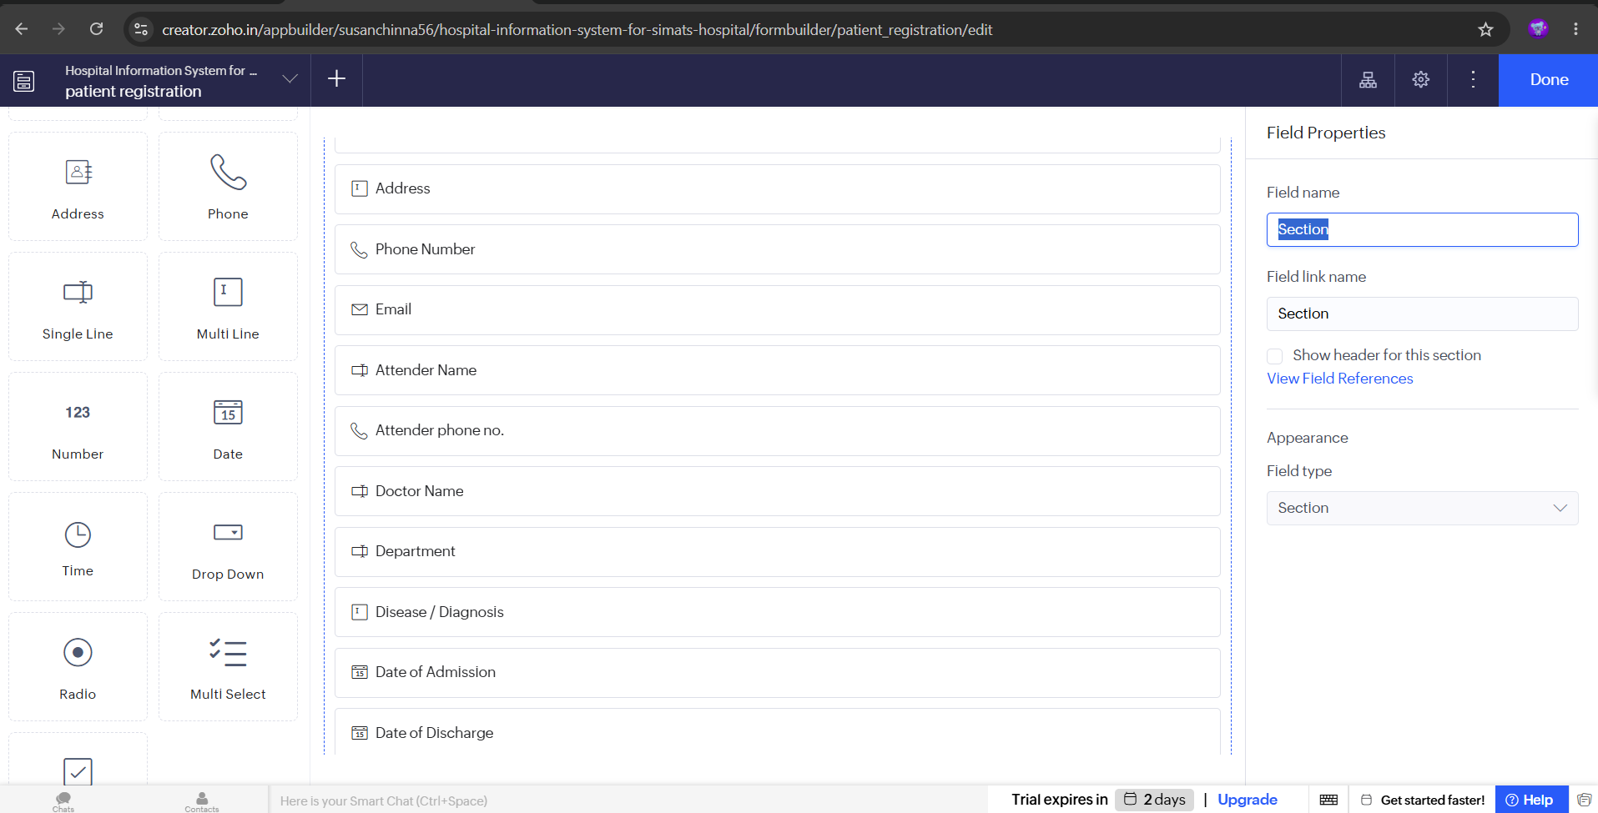
Output

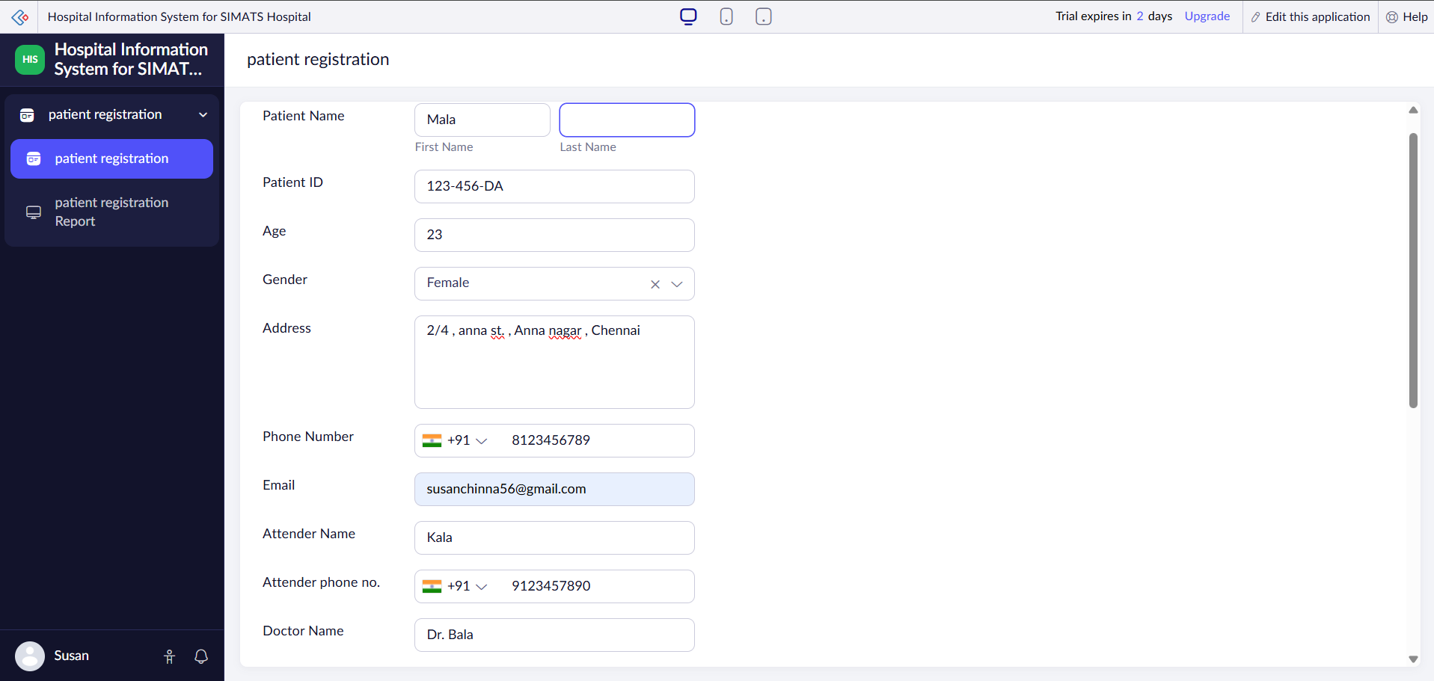

Result
Thus, a cloud-based Hospital Information System was successfully created using Zoho Creator. The application efficiently manages patient registration, medical records, and attender details while securely storing the information in the cloud, thereby demonstrating the Software as a Service (SaaS) model.

Experiment No. 10

Student Information System (C Program Execution) – SaaS

Aim
To create a cloud-based Student Information System using Zoho Creator to demonstrate the Software as a Service (SaaS) model. The application is designed to maintain student information such as personal details, academic records, attendance, and semester mark sheets, which can be used as input for displaying student information through a C program.

Software/Tools Required
- Zoho Creator
- Web Browser (Google Chrome/Microsoft Edge)
- Zoho Account
- Internet Connection
- GCC Compiler / Online C Compiler (for executing the C program)

Algorithm
- Log in to Zoho Creator.
- Create a new application named Student Information System.
- Design a student information form.
- Add all the required personal and academic fields with appropriate field types.
- Configure validation rules for fields such as email, phone number, and register number.
- Save the application and enter sample student records.
- Verify that the student information is stored successfully in the cloud database and use the stored data as input for displaying student information in a C program.

Form Fields
Field Name | Field Type
Student Name | Single Line
Register Number | Single Line
Age | Number
Gender | Dropdown
Address | Multi Line
Phone Number | Phone
Email Address | Email
Department | Dropdown
Course | Single Line
Semester | Number
Grade | Dropdown
Attendance Percentage | Decimal
Progress Report | Multi Line
Semester Mark Sheet | File Upload
Remarks | Multi Line

Output

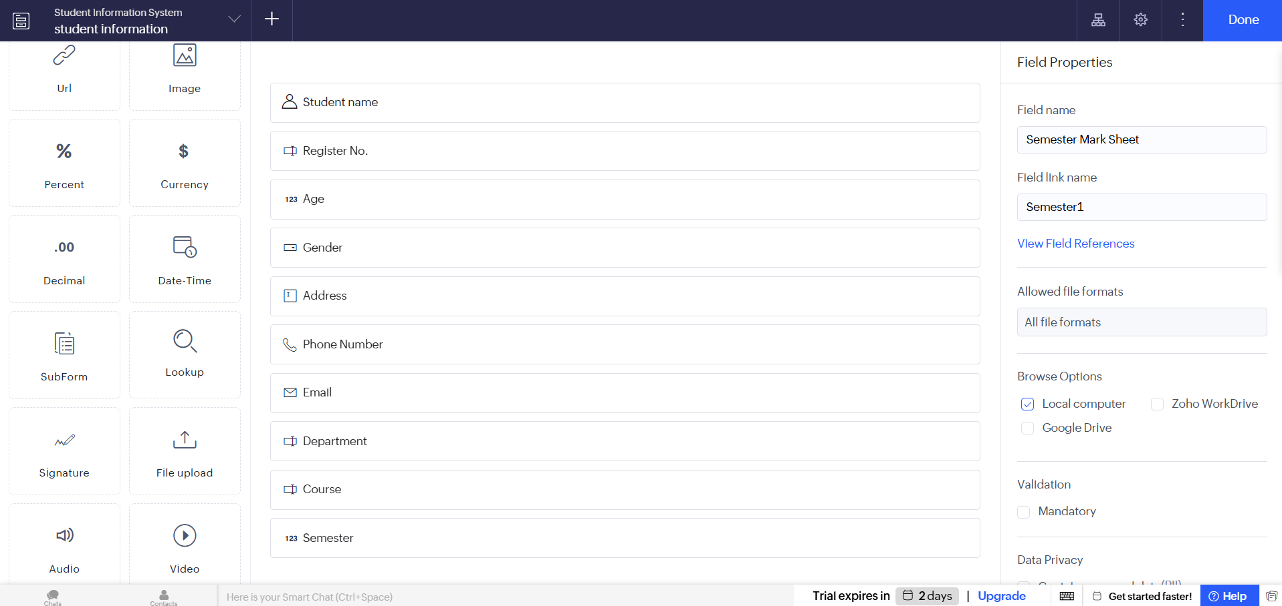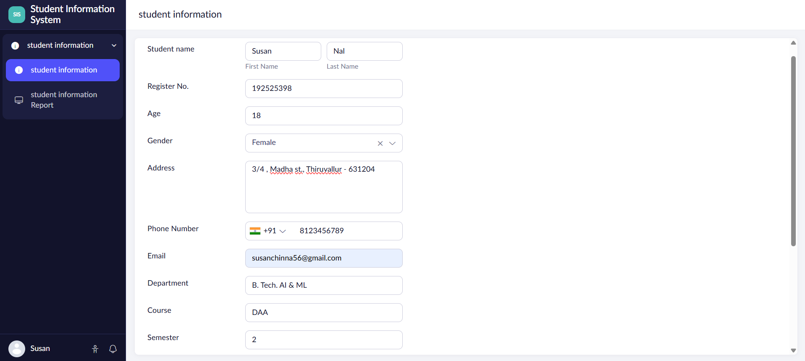

Result
Thus, a cloud-based Student Information System was successfully created using Zoho Creator. The application securely stores student personal and academic information in the cloud, enabling easy management of records and providing the required data for displaying student information through a C program, thereby demonstrating the Software as a Service (SaaS) model.

Experiment No. 11

Online Super Market System – SaaS

Aim
To create a cloud-based Online Super Market System using Zoho Creator to demonstrate the Software as a Service (SaaS) model. The application enables customers to place online grocery orders, classify items into different categories, calculate the total bill, and securely store customer and order details in the cloud.

Software/Tools Required
- Zoho Creator
- Web Browser (Google Chrome/Microsoft Edge)
- Zoho Account
- Internet Connection

Algorithm
- Log in to Zoho Creator.
- Create a new application named Online Super Market System.
- Design an online shopping order form.
- Add all the required customer, product, and order-related fields with appropriate field types.
- Configure item categories, quantity, price, and formula fields to calculate the total amount.
- Save the application and enter sample customer order details.
- Verify that the order information is stored successfully in the cloud database and can be viewed or managed whenever required.

Form Fields
Field Name | Field Type
Customer Name | Single Line
Customer ID | Single Line
Address | Multi Line
Phone Number | Phone
Email Address | Email
Item Category | Dropdown (Fruits, Vegetables, Dairy, Beverages, Snacks, Grocery, Personal Care, Others)
Item Name | Single Line
Quantity | Number
Unit Price | Currency
Total Amount | Formula (Currency)
Payment Method | Dropdown (Cash on Delivery, UPI, Credit/Debit Card, Net Banking)
Order Date | Date
Delivery Address | Multi Line
Order Status | Dropdown (Pending, Confirmed, Shipped, Delivered, Cancelled)
Remarks | Multi Line

Output

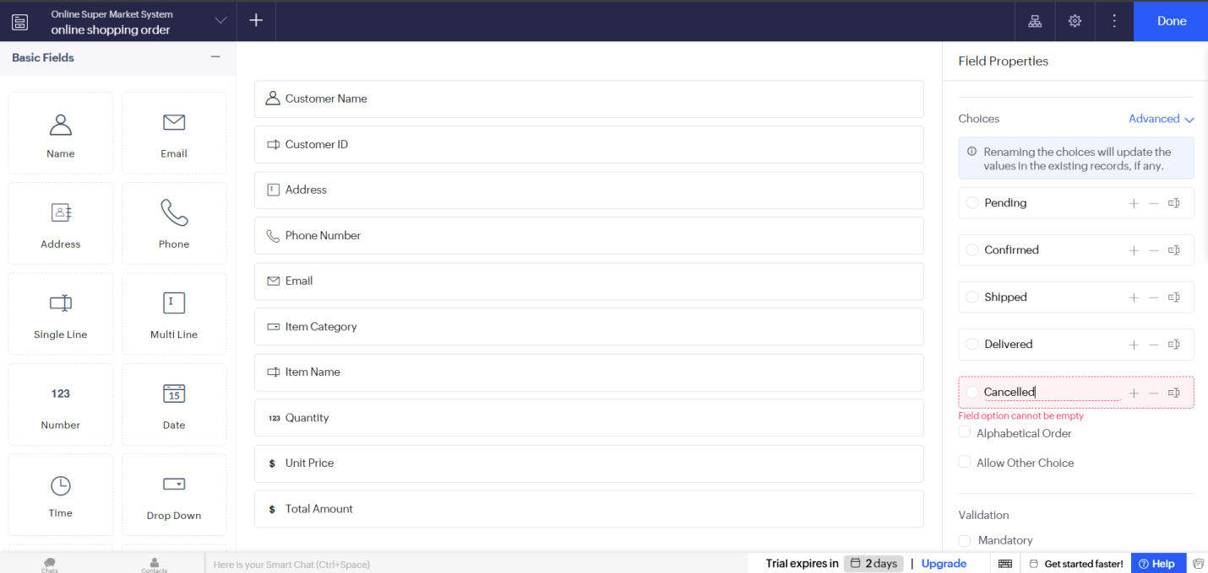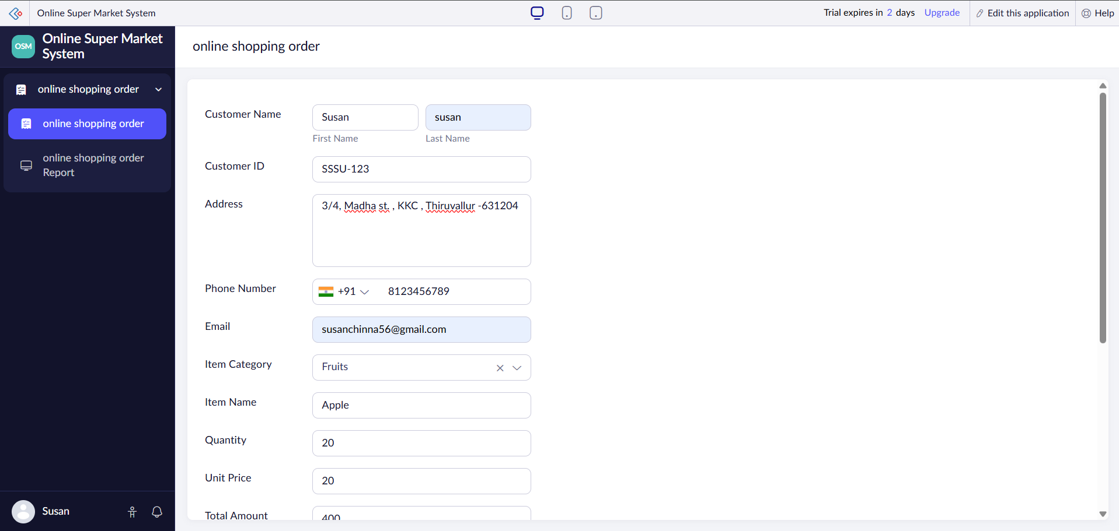

Result
Thus, a cloud-based Online Super Market System was successfully created using Zoho Creator. The application enables customers to place online orders, categorize products, calculate the total bill automatically, and securely store order details in the cloud, thereby demonstrating the Software as a Service (SaaS) model.

